**Infy Credit Card Inc.**

**Sequence Diagrams**



**Education & Research Department**

**© Infosys Technologies Ltd**



|  |  |  |  |  |
| --- | --- | --- | --- | --- |
| **VersionRevision** | **Date** | **Authors** | **Reviewed by** | **Description** |
| 1.00 | 22 May, 2010 | Ashwini K J | Ashwini K J |  |

|  |  |  |  |  |
| --- | --- | --- | --- | --- |
| **Version Revision** | **Date** | **Author** | **Reviewed by** | **Description** |
| 1.00 | Jun 2009 |  |  | Initial draft |

Table of Contents

1. Sequence Diagrams 3

1.1. Login 3

1.2. Choose Scheme 4

1.3. View Card Details 4

1.4. Card Usage Details 4

1.5. Online Transaction 5

1.6. Payment 5

1.7. Apply Card 6

1.8. Approve Card 6

1.9. Block Card 6

1.10. Unblock Card 7

1.11. Transaction Statistics 7

1.12. Blocked Card Statistics 7

1.13. Revenue Statistics 7

1.14. Approved & Rejected Card Report 8

# Sequence Diagrams

## Login

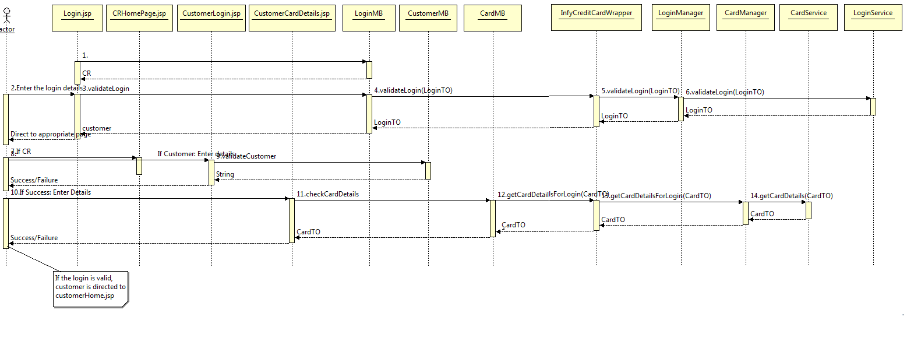

Note : ([HttpSession](http://java.sun.com/javaee/5/docs/api/javax/servlet/http/HttpSession.html))FacesContext.getCurrentIstance().getExternalContext().getSession() would return the HttpSession object within the managed bean. Once you get the session object, set username, cardNo in the session object.

HttpSession session = session = ([HttpSession](http://java.sun.com/javaee/5/docs/api/javax/servlet/http/HttpSession.html))FacesContext.getCurrentIstance().getExternalContext().getSession();

## Choose Scheme

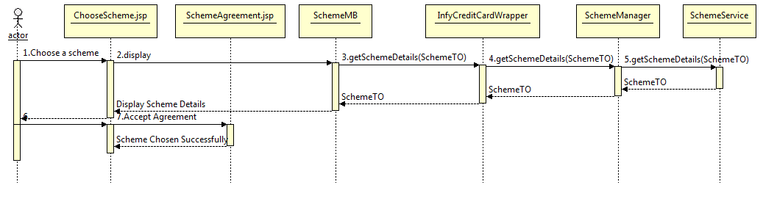

## View Card Details

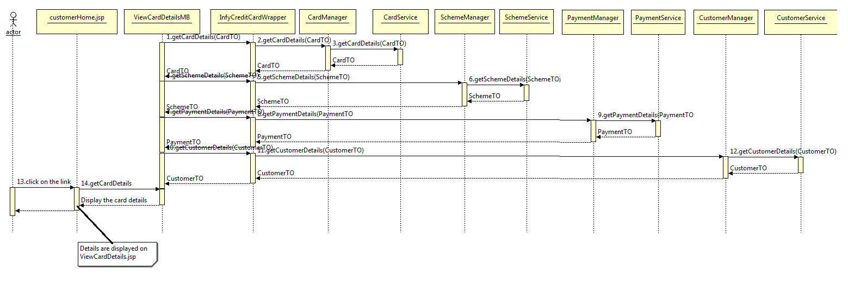

## Card Usage Details

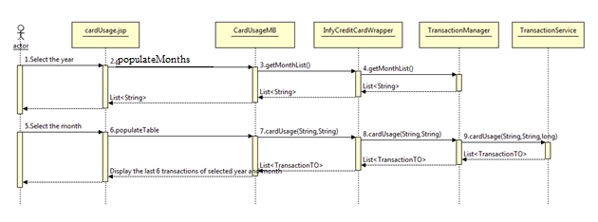

## Online Transaction

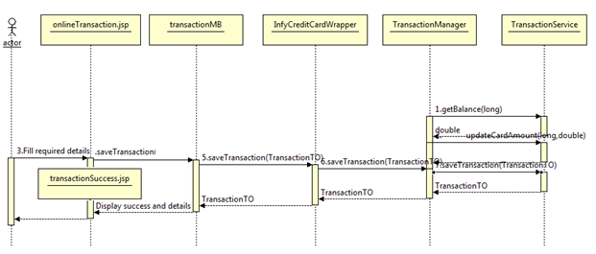

## Payment

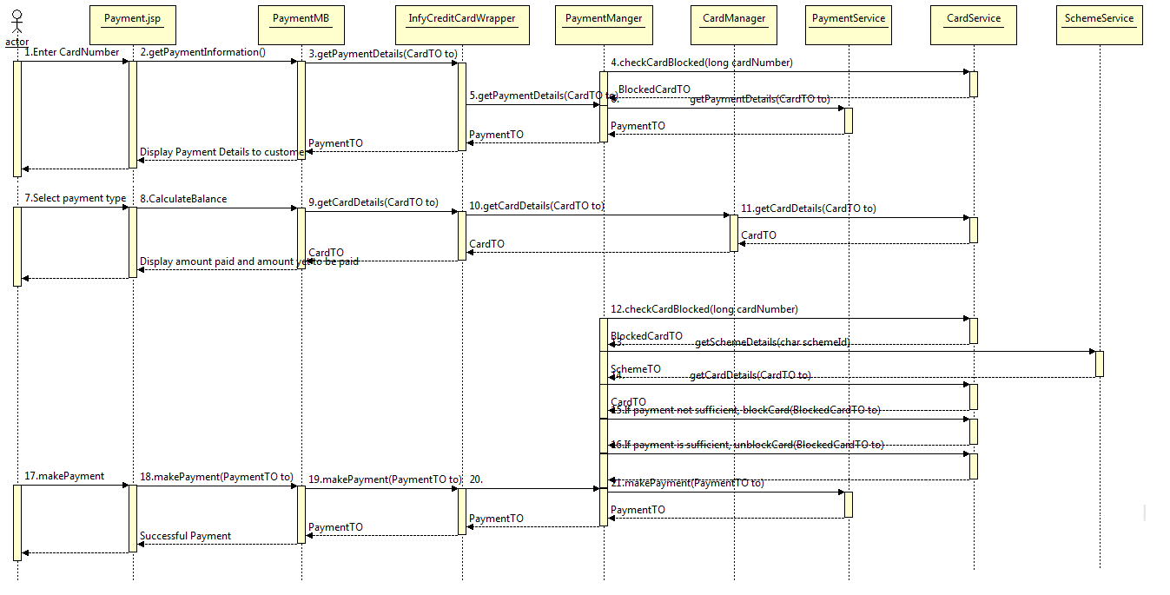

## Apply Card

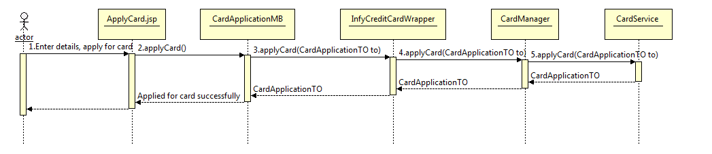

## Approve Card

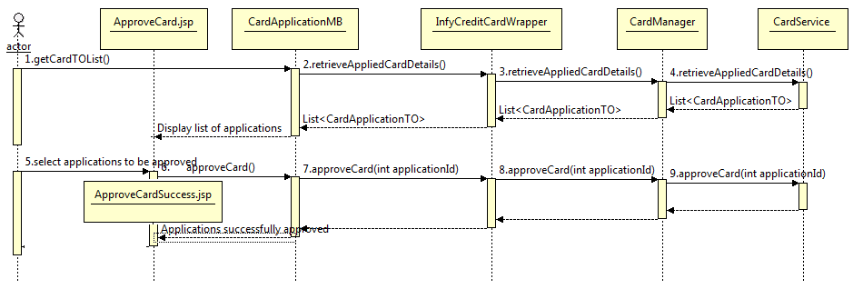

## Block Card

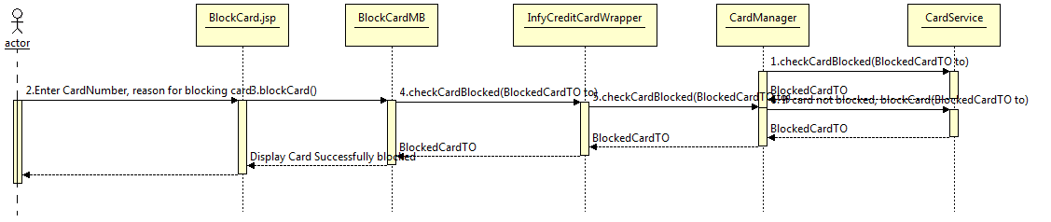

## Unblock Card

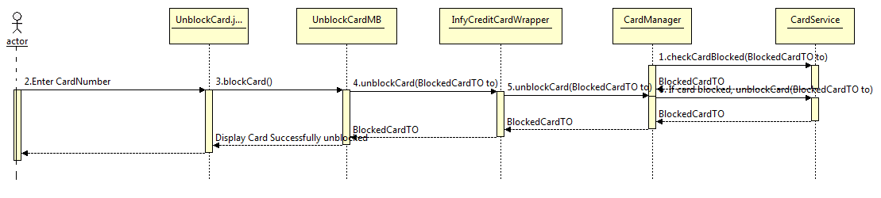

## Transaction Statistics

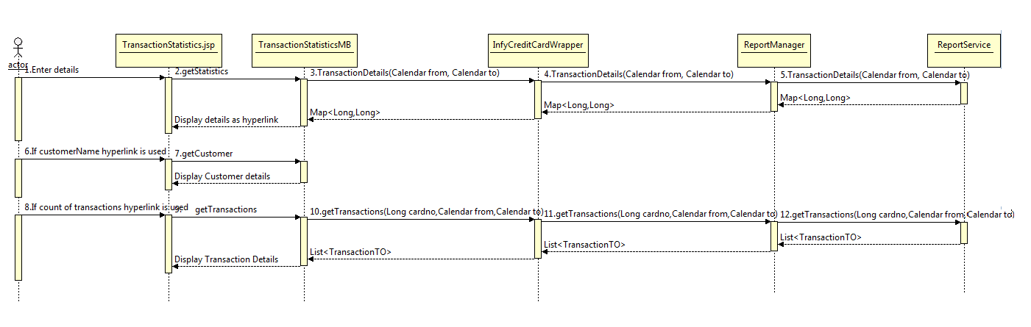

## Blocked Card Statistics

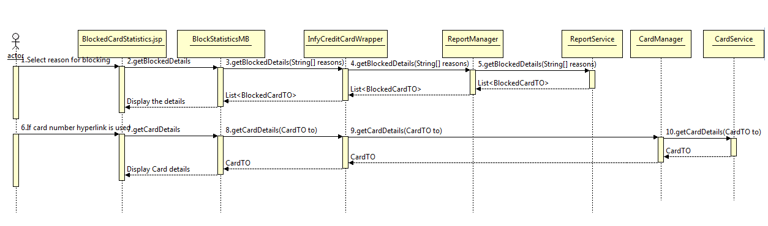

## Revenue Statistics

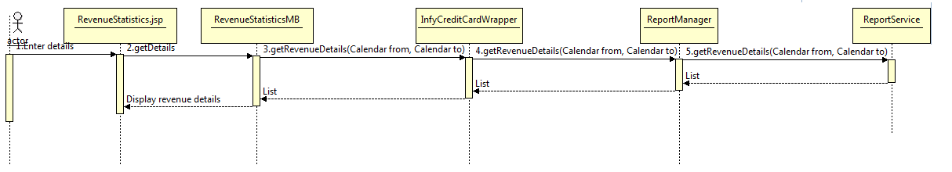

## Approved & Rejected Card Report

